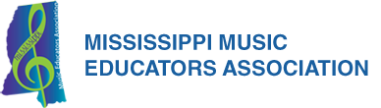

2019 ACDA/MMEA Convention
Hotel Blocks

Red Lion Hotel  4301 Hardy St  Hattiesburg, MS 39402  601-606-9497  $95.00 | Courtyard  119 Grand Dr  Hattiesburg, MS 39401  601-238-3050  $119.00 | Residence Inn  116 Grand Dr  Hattiesburg, MS 39401  601-294-9202  $125.00
Hilton Garden Inn  133 Plaza Dr  Hattiesburg, MS 39402  601-261-3770  $119.00 | Home2 Suites  116 Plaza Dr  Hattiesburg, MS 39402  601-261-3800  $124.00 | Hampton Inn  120 Plaza Dr  Hattiesburg, MS 39402  601-268-0606  $124.00
Towne Place  235 Thornhill Dr  Hattiesburg, MS 39402  601-582-2030  $109.00 - $119.00 | Fairfield Inn  173 Thornhill Dr  Hattiesburg, MS 39402  601-296-7777  $99.00 | Doubletree  10 Gateway Dr  Hattiesburg, MS 39402  601-296-0302  $119.00

***Please make sure you inform the hotel that you are attending the ACDA/MMEA Convention***

